Expert Lecture on “Optical Fibre (Physics)”
Date :- 28/11/2024
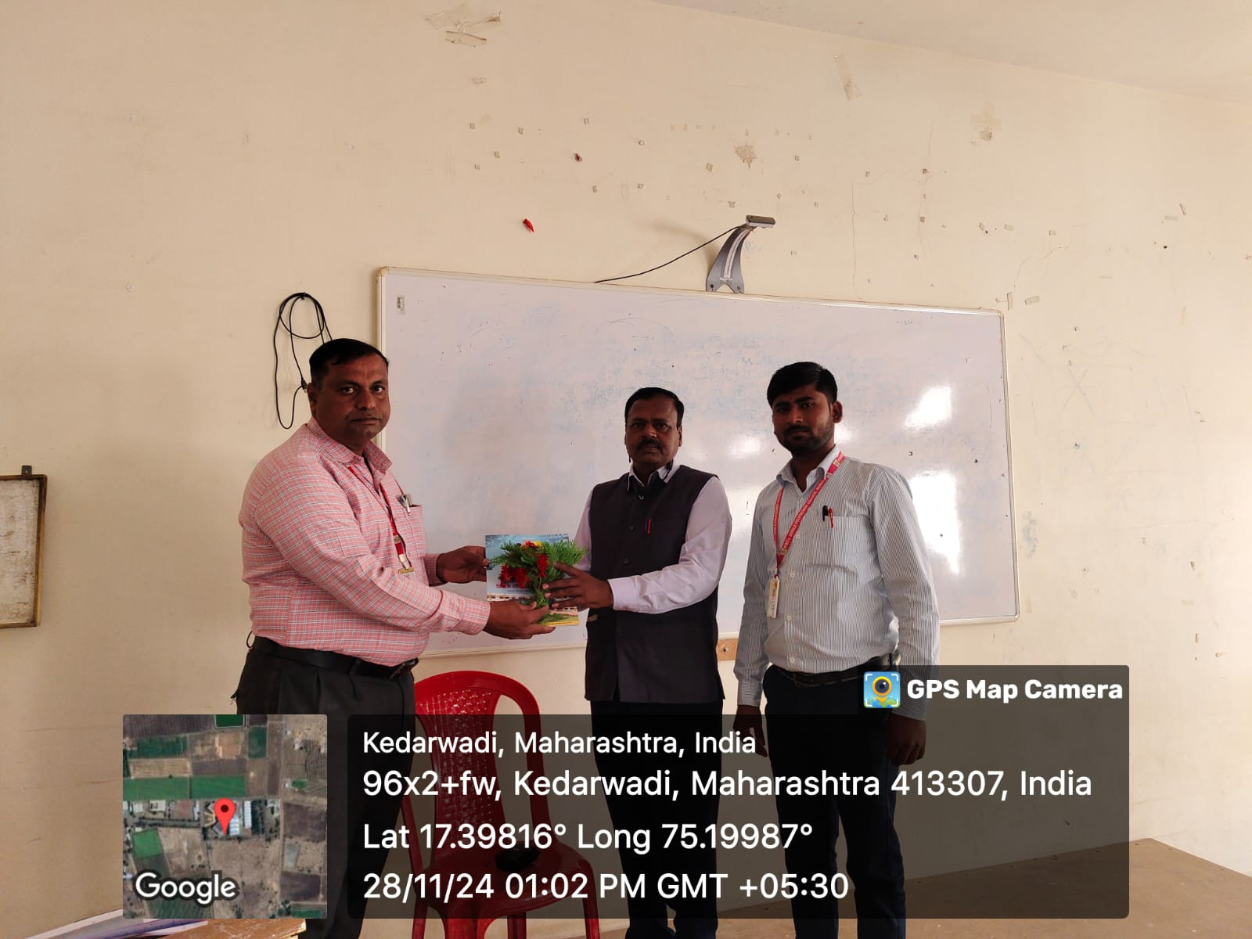Chief Guest Mr.N.V.Borade Felicated by Mr.P.G.Pawar General Science HOD , Mr. S.D.Aldar Chemistry Lecturer.
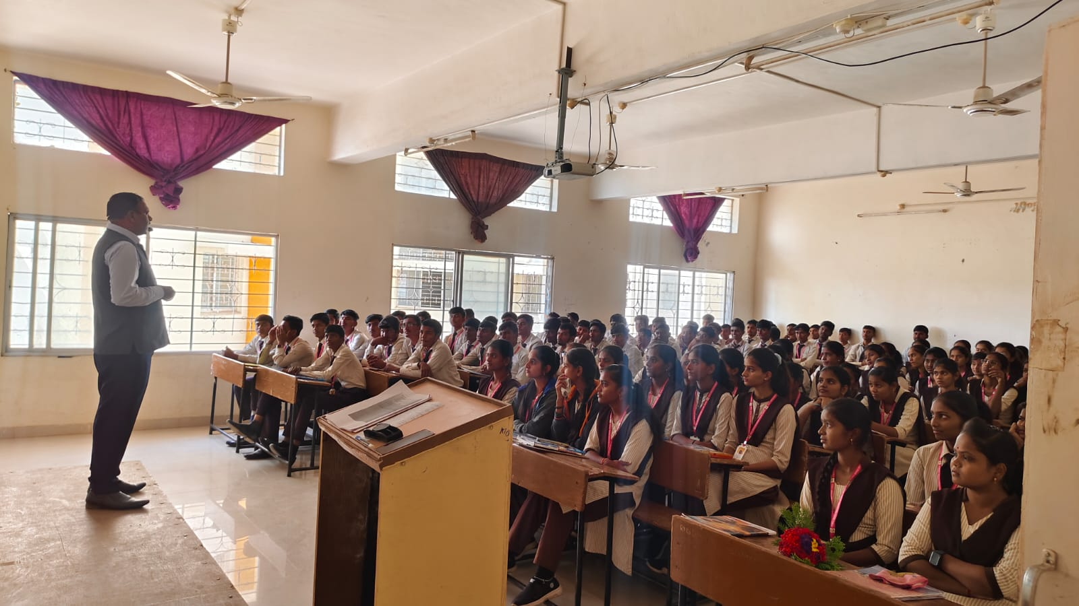 Mr.N.V.Borade Conducting Expert Lecture On “Optical fibre”For First Year Student.
Expert Lecture on “Yoga & Meditation”
Date :- 3/10/2024
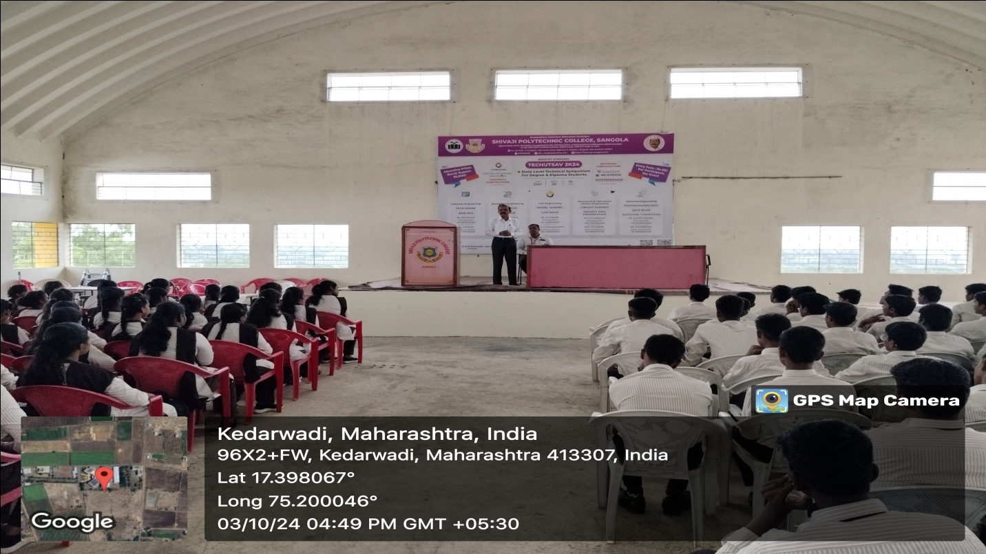
Mr.S.K.Raut Conducting Expert Lecture On “Yoga & Meditation”For First Year Student.
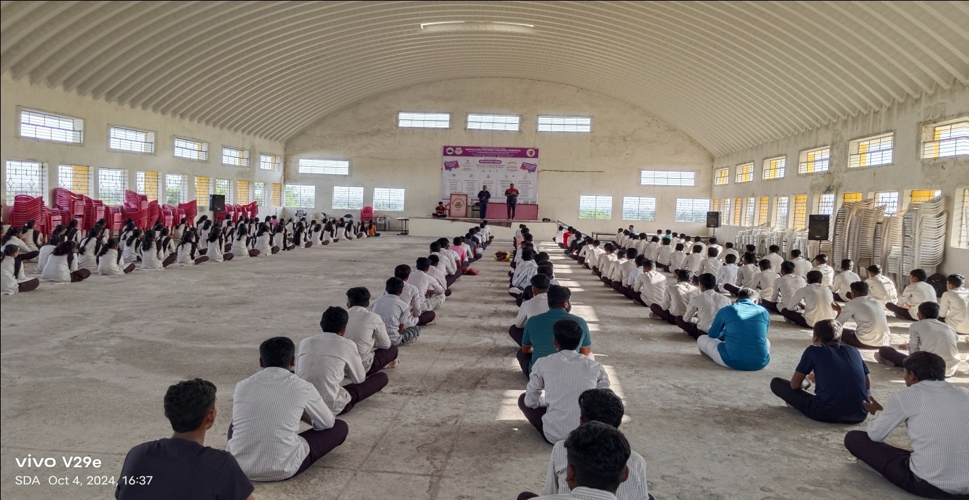
Expert Lecture on “Electrical”
Date :- 24/03/2025
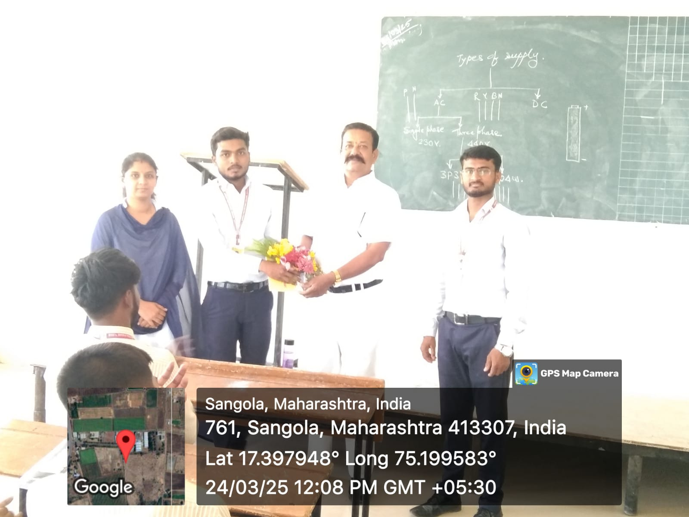
Chief Guest Mr.V.S.Gaikwad Felicated by Mr.A.A.Shivsharan Incharge HoD Of Electrical Department.
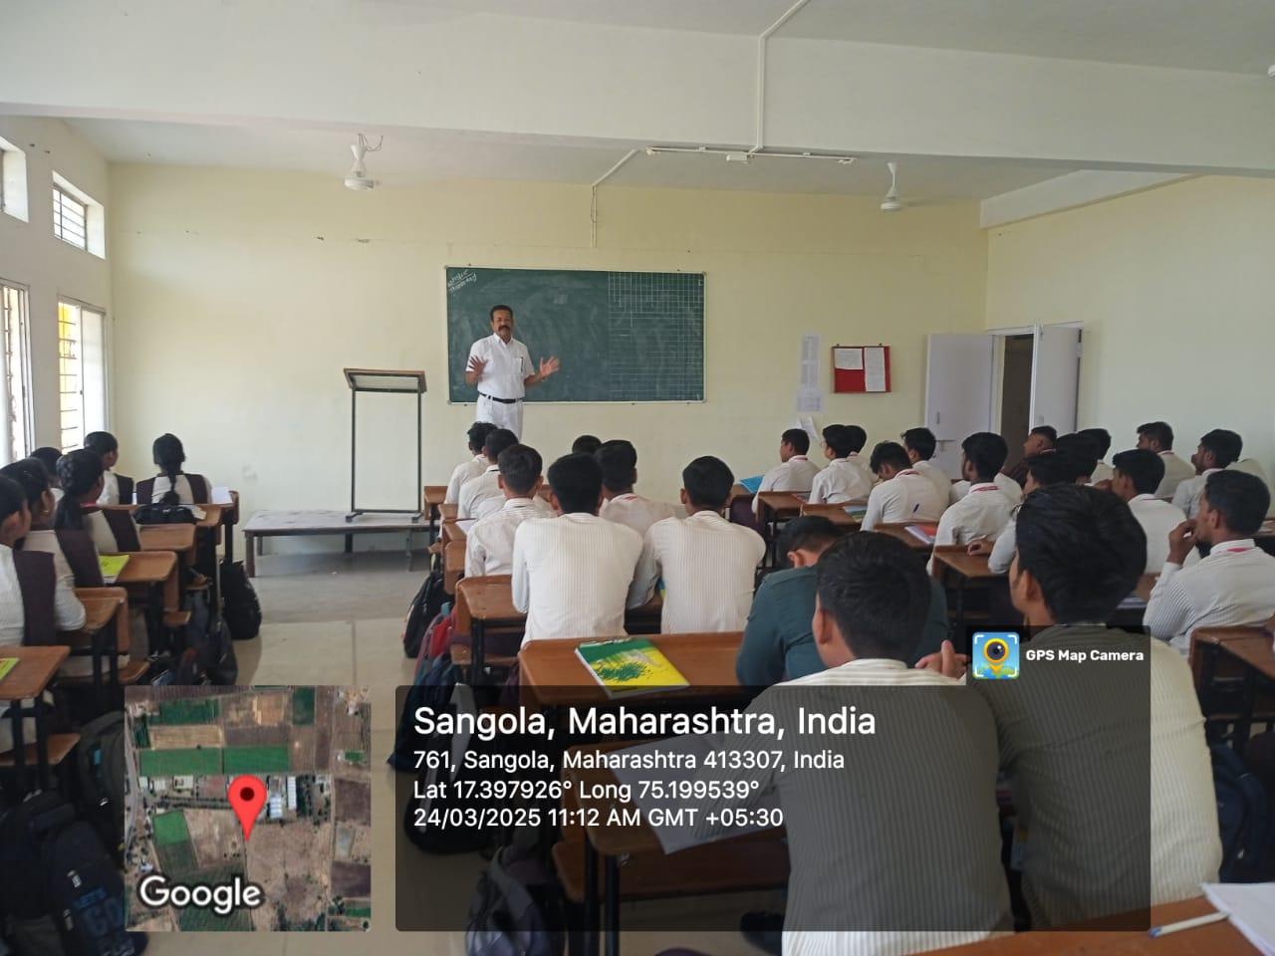Mr.V.S.Gaikwad Conducting Expert Lecture On “Fundamental of Electrical Engineering” For First Year Electrical Student.
Expert Lecture on “Professional Communication”
Date :- 16/10/2025
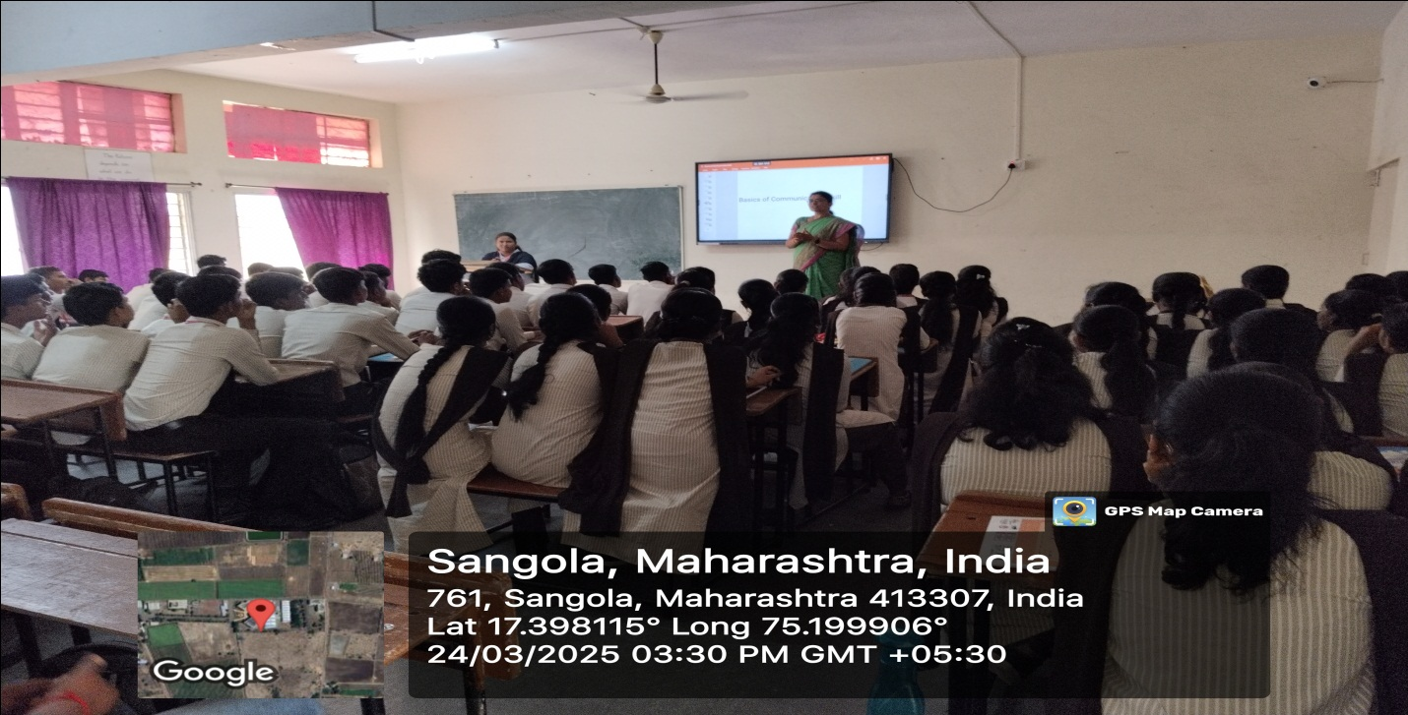
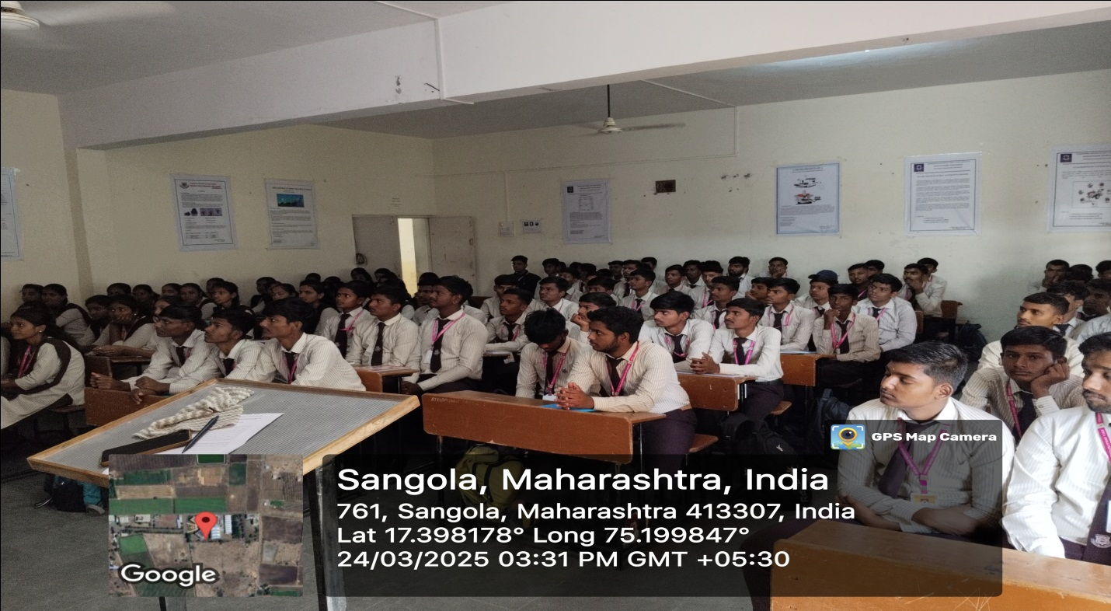
Dr.B.S.Patil Conducting Expert Lecture On “ Communication Skill” For all First Year Student.
Expert Lecture on “C Programming”
Date :- 16/03/2025
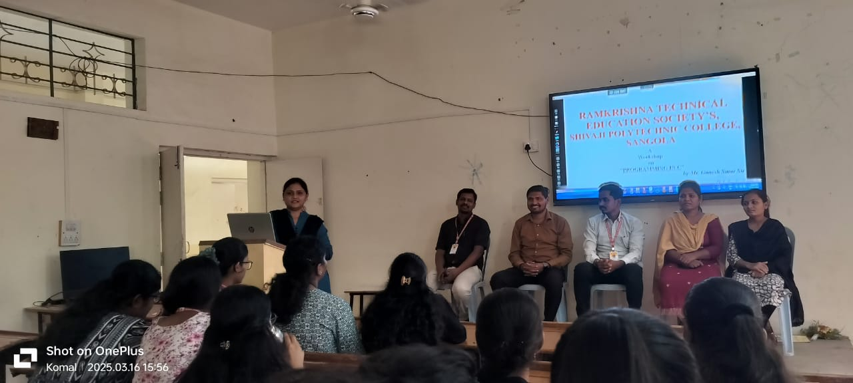
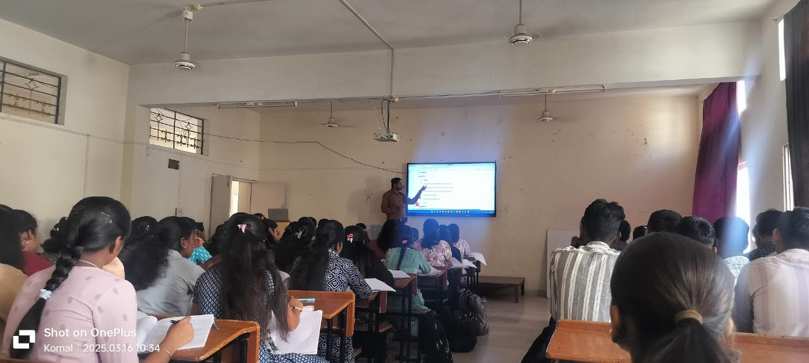
Mr.Sutar Conducting Expert Lecture On “C Programming” For First Year all Student.
Expert Lecture on “Manufacture Technology”
Date :- 14/03/2025
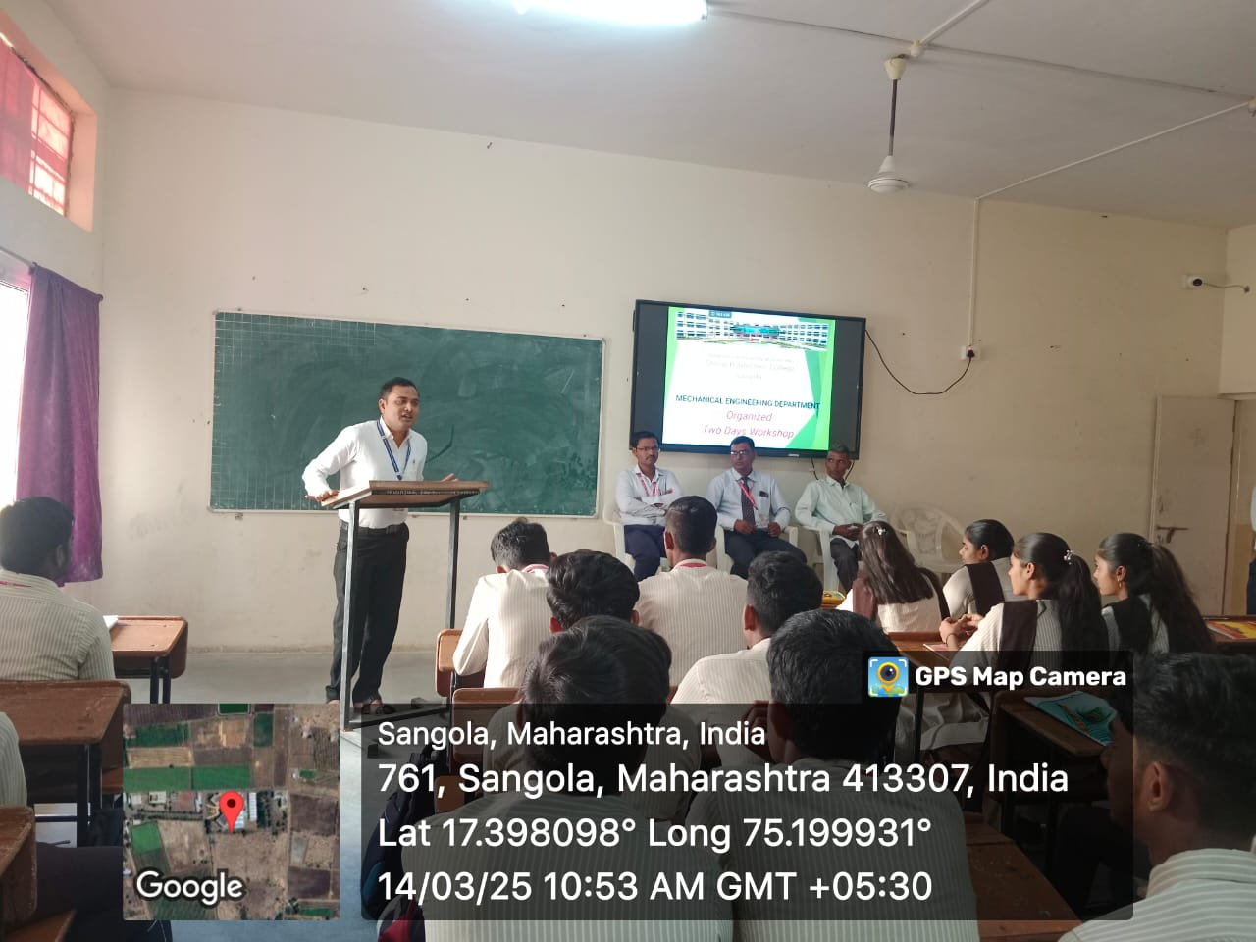
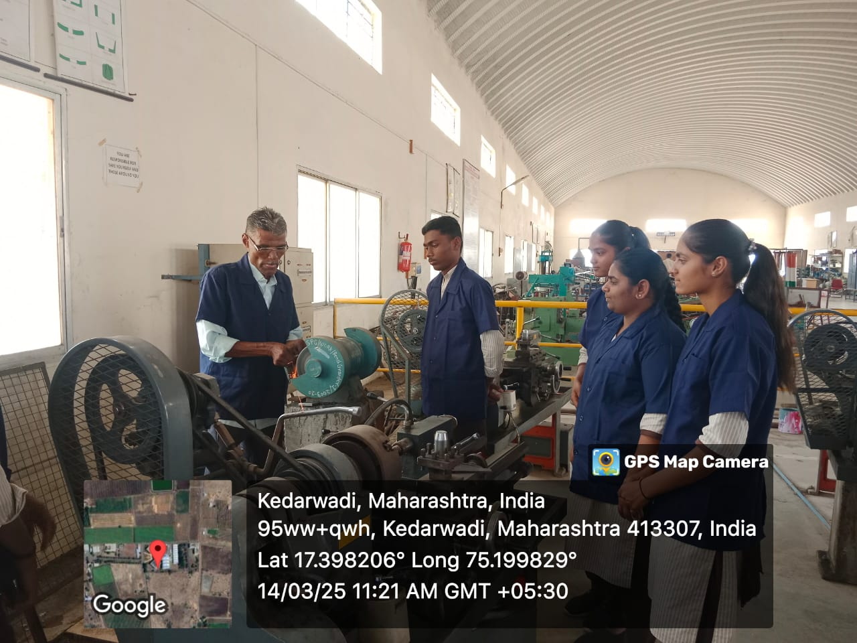
Mr.A.Y.Shingare Conducting Expert Lecture On “Manufacturing Technology” For First Year Mechanical Student.
Expert Lecture on “Social & Life skills”
Date :- 26/03/2025
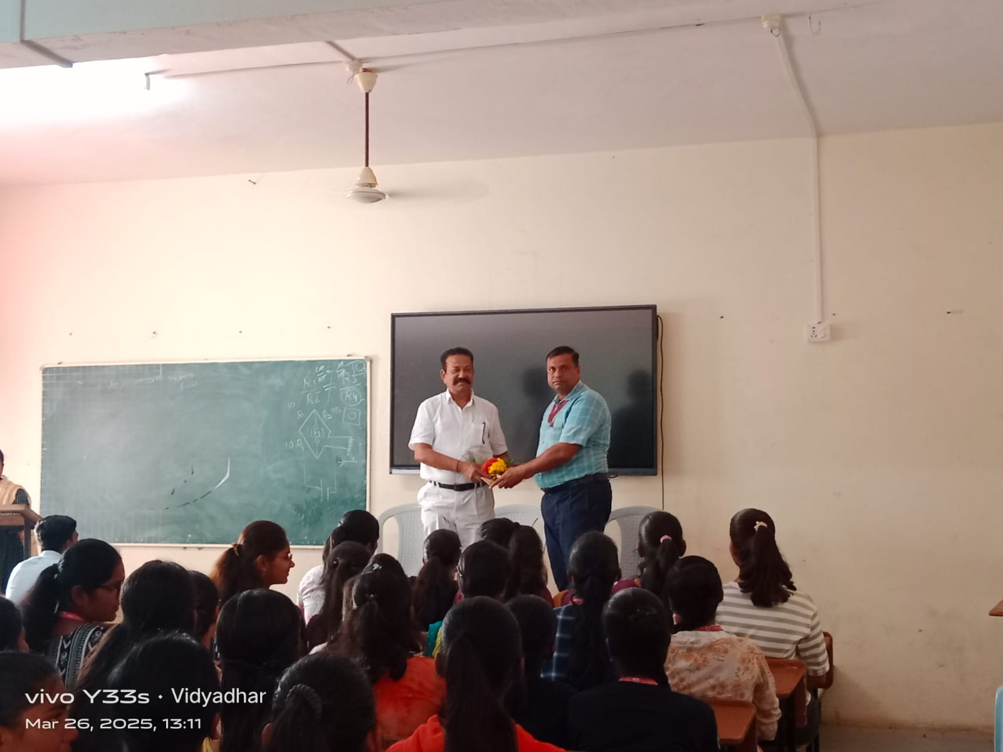Chief Guest Mr.V.S.Gaikwad Felicated by Mr.P.G.Pawar HoD Of General Science & Humanities .
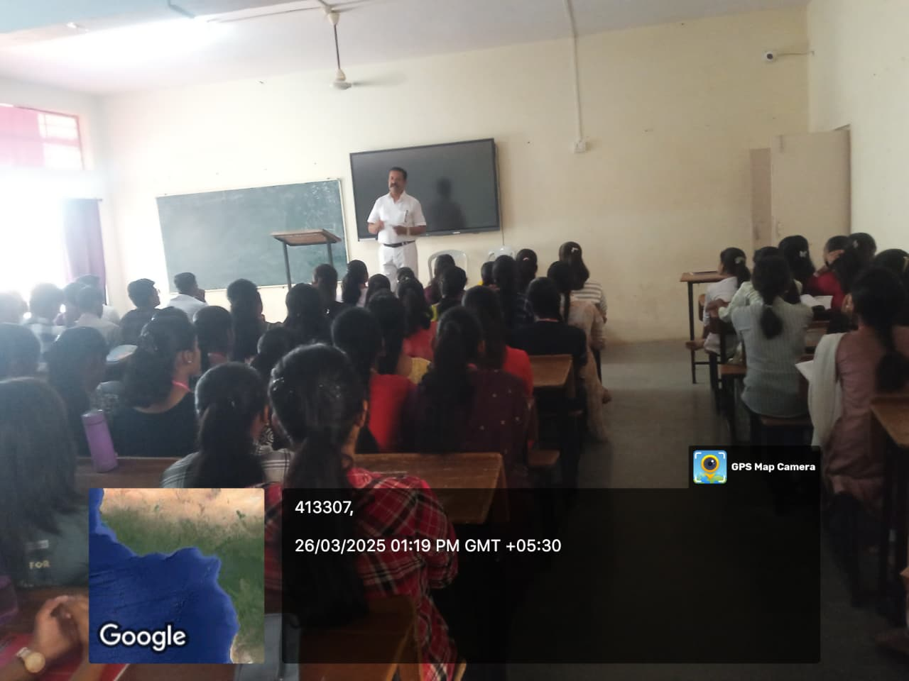Mr.V.S.Gaikwad Conducting Expert Lecture On “Social & Life skills” For First Year Computer & Civil Student.

